Inter School Quiz on Earthquake Tips
National Information Centre of Earthquake Engineering (NICEE) at IIT Kanpur conducted the final round of the inter school quiz competition on Earthquake Tips on 07 Feb 2012 at Outreach Auditorium, Indian Institute of Technology Kanpur, Kanpur. The preliminary rounds of the quiz were conducted in Kanpur, Indore, Nagpur, Ambala, Chandigarh, Pune, Mumbai, Ahmedabad, Jabalpur, Delhi, Shimla and Lucknow.

To spread the message of seismic safety, NICEE always felt an urge to include school children, who are the future builders of the country, in the activity of furthering this cause towards ensuring an earthquake resistant built environment in the country. This year there was an overwhelming response from the schools for registering for the quiz. More than 100 schools from about 50 cities showed their willingness to participate in the quiz this year. The registering schools were given 50 copies of “Earthquake Tips” by Dr. CVR Murty, to be used for selecting a team of four participants from each school from Class VIII to Class XI.

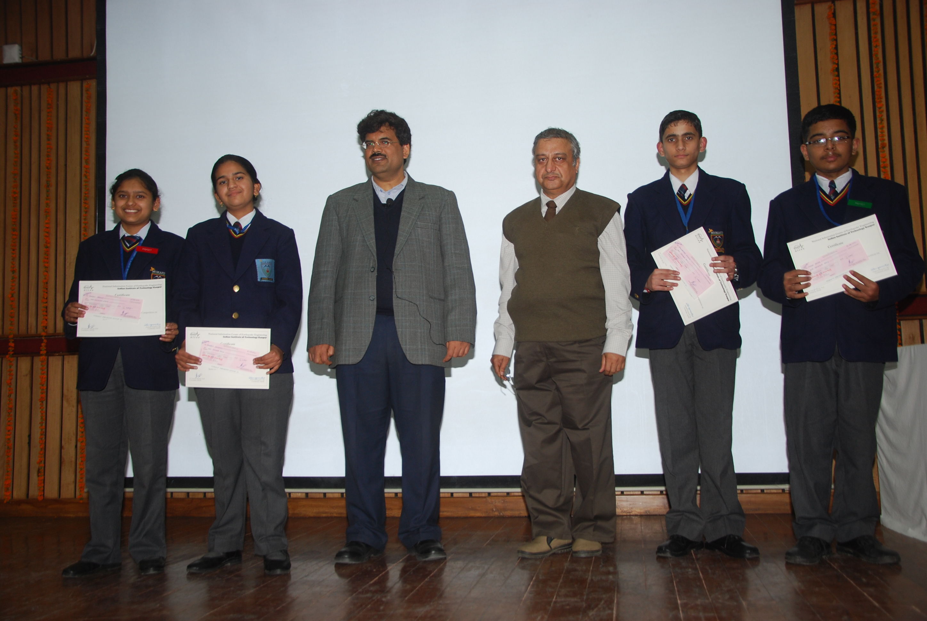
Winning Team of Mukund Lal Public School, Yamuna Nagar

In the final round of the quiz on 07 February, 14 schools - who were the winners of their respective preliminary rounds, viz. VSEC, Avadhpuri, Kanpur; City Montessori School, Station Road, Lucknow; Green Fields School, Safdarjung, New Delhi ; ITL Public School, Dwarka, New Delhi; Mukund Lal Public School, Yamuna Nagar; Mount Carmel School, Chandigarh; Sainik School, Rewa; Bhavan’s Bhagwandas Purohit Vidya Mandir, Nagpur; Rishi Public School, Gurgaon; Dayanand Public School, Shimla; Christ Church Girls Senior Secondary School, Jabalpur; City Pride School, Pune; Pawar Public School, Mumbai and Smt. Sandraben Shroff Gyandham School, Vapi participated.

The quiz had four rounds viz. Round Robin, Picture Round, Rapid Fire Round and Lucky number Round. The questions were based on the publication “Earthquake Tips” by Dr. CVR Murty. The winning team from Mukund Lal Public School, Yamuna Nagar scored 80 points. Christ Church Girls Senior Secondary School, Jabalpur came second scoring 73 points and Bhavan’s Bhagwandas Purohit Vidya Mandir, Nagpur came third with 67 points.

After the quiz, Prof. Durgesh C. Rai explained the nitty-gritty’s of earthquake and its mitigation to the participants of the quiz. He expressed his surprise over the grasp of the subject which was shown by the participants while answering the questions posed to them during the quiz.

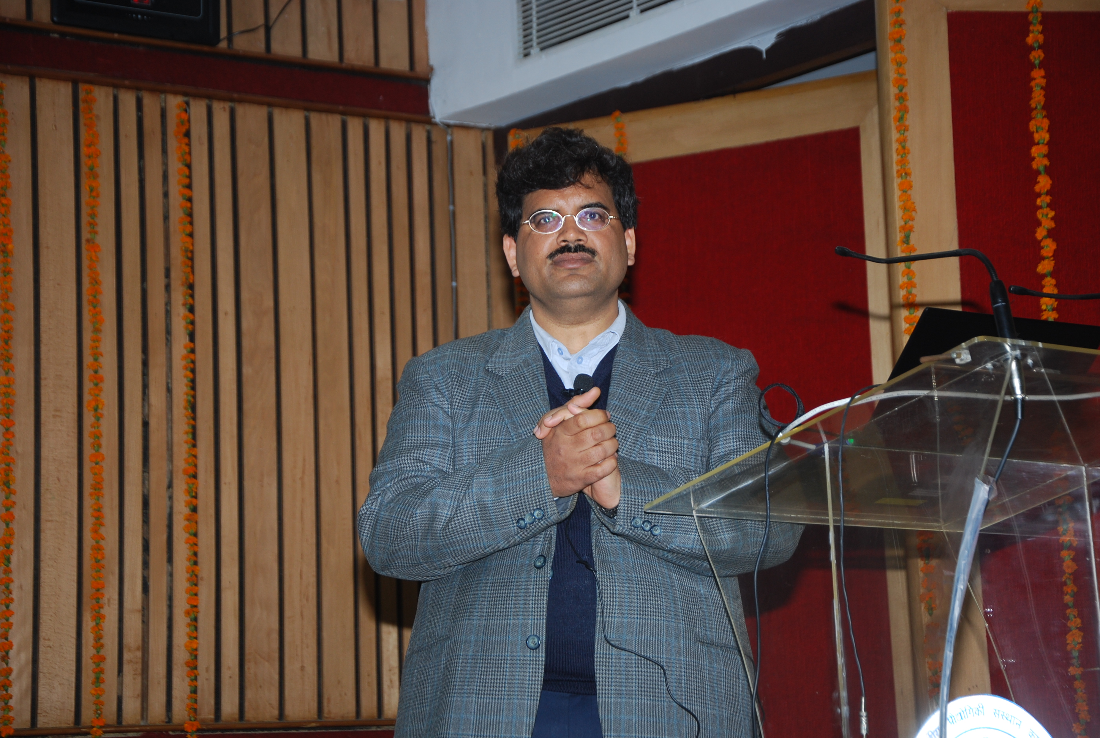

This is an annual event of NICEE and has been conducted consecutively for the third year since 2009-10. The schools are approached in the month of March and schools showing willingness to participate are given 50 copies of the publication for distribution to interested students from whom the schools can select their team of four students. For further details and queries, if any, please contact, Suresh Ailawadi, Consultant, NICEE at 9450162502 or e-mail at asuresh@iitk.ac.in.

